1-2 Assignment: Preparing the Development Environment

Romi’on Price
Southern New Hampshire University
CS-330 Comp Graphic and Visualization
Professor Iles
July 5, 2026

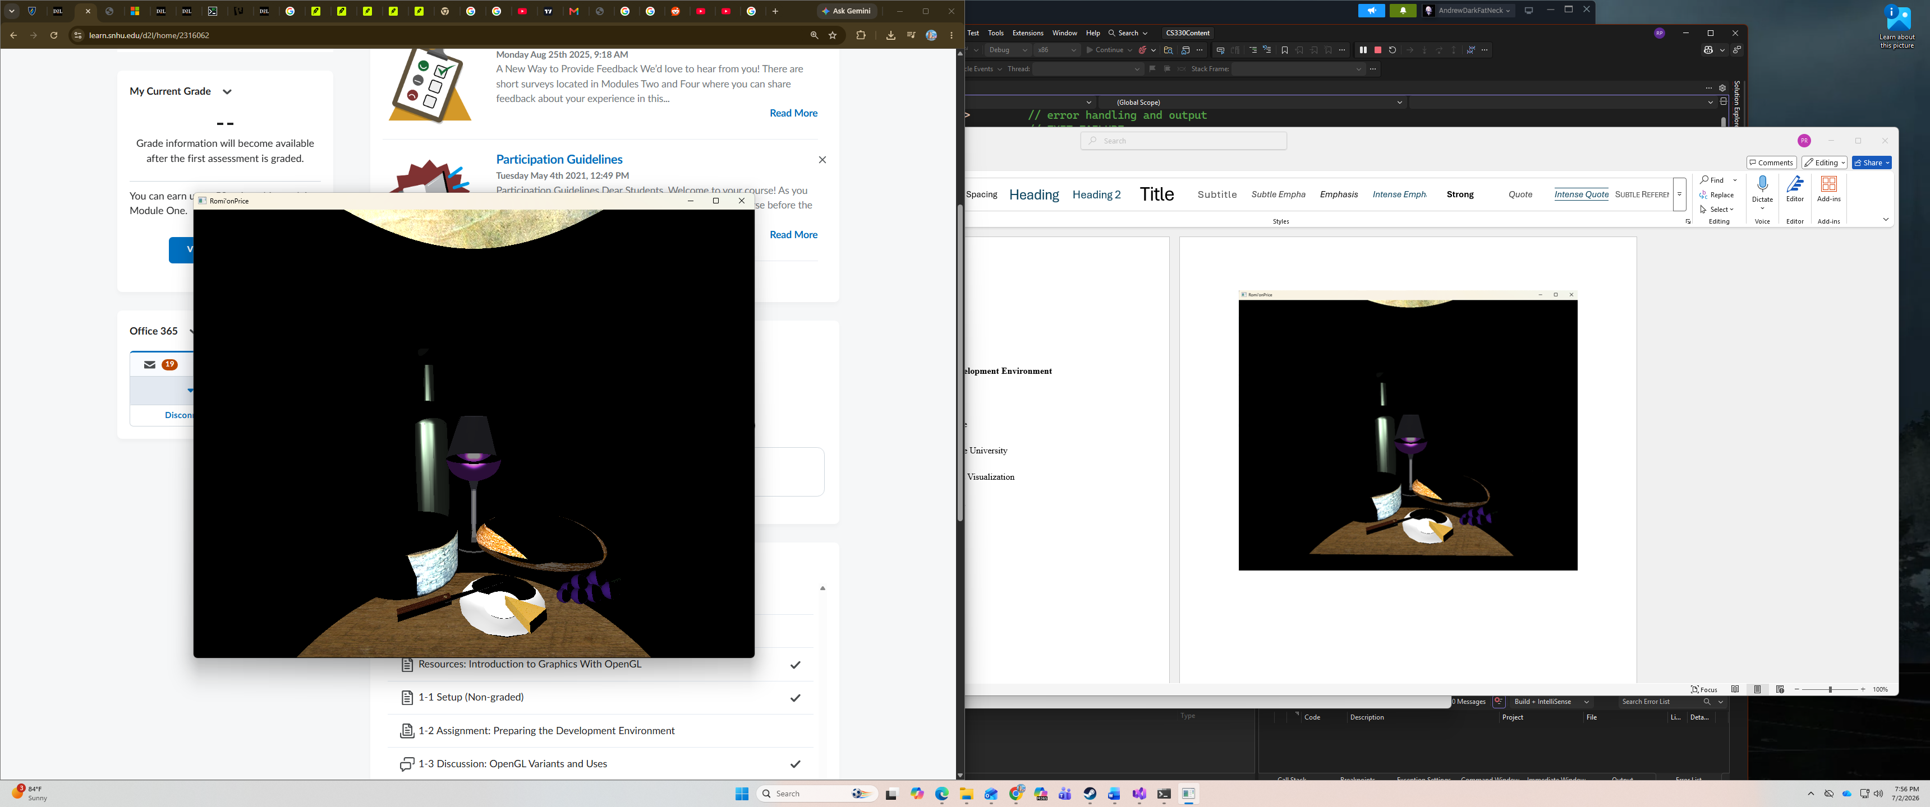
Overall, I didn’t have any challenges setting up OpenGL, but rather with visual studio. The code wouldn’t compile at first due to all configurations not being set and the platform toolset not being properly set for me. I was able to run the code after I rebuilt the solution. The Assignment itself was pretty self-explanatory, I was able to run the code and display the requested 3D scene and change the title to my name.

